CAETS 2020 Energy Report

Country Analysis Questionnaire
Working Title: Solutions for High-level Penetration of Intermittent Renewable Energy

Overview
The focus of this paper is how countries worldwide are each making the energy transition towards clean energy systems, whilst dealing with the inevitable problems of energy intermittency. This paper will attempt to address two suggestions to an audience of political authority looking for expert advisory: first, addressing how renewable stabilizing technologies are being implemented en masse, and second, discussing market-based policy regulations that attempt to mitigate problems caused by intermittency.
Please fill out the questionnaire by September 15th, 2019, regarding to your country’s situation and your academy’s view. Altogether, please limit your response to less than 5 pages, and give short 2-3 sentence answers or bullet points. If possible, use charts, tables, references and other data measures.
Remember this data is to be juxtaposed against other countries policies. Pick and expand upon issue areas that are widely relevant, and not just niche markets. If applicable, you may indicate where scientific evidence or assessments by your academy differ from the official national policy. Also, clearly demarcate instances of where you think your country deviates from most other countries.

Target Audience
- Members of international academies
- International bodies such as United Nations SDG, Mission Innovation, etc.
- Written for political advisory & policymakers

- Introduction
  - Energy Status Quo
    - What is the current national energy portfolio, as of 2018*? Please include any data graphics describing the energy mix in your country, along with data in this table format (below):
*Please include a separate table with current 2019 figures if available. If neither have not yet been compiled, please use 2017 metrics.
2018* Data | Amount/Rate

Power generation amount (GWh)

Power generation ratio (% of total generation)

Top 3 renewable energy sources

Growth rate of total renewable generation (% per year) over the past five years

  - Future Milestones
    - Looking ahead to 2040 (or 2050),
      - What are future goals (national for renewable growth rates)?
      - Using the same metrics as asked in Q1a, what is the trajectory or national strategy for these energy policy in your current administration? (include table)
        - What are the target milestone years?
        - What are the benchmarks of progress for improvement metrics?
  - Problems in Intermittency
    - How severe is the problem of electric isolation, electric ‘islands’ or isolated grids?
    - Is your country experiencing a Duck Curve phenomenon? (ex. Denmark)
      - If yes, discuss well-known or severe case studies and include a duck curve chart that captures generation data from over the past 5-10 years (example below). If no, please discuss effective grid management techniques (or others) that prevented this phenomenon from occurring.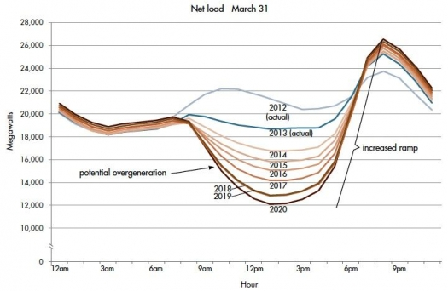
      - What are some steps that have been taken to mitigate this phenomenon?
      - In efforts to mitigate, is the power system of your country interconnected to the system of another large body, such as another country or international system to increase control of supply-demand?
      - What steps are being taken to correct the level of energy isolation to bring it to greater efficiency?
- The Solution Part 1: Technologies That Streamline Implementation
  - What are some typical or latest technologies that attempt to mitigate problems of intermittency that your country is making strides in?
  - What is the primary storage system that being used or is being developed?
  - Are there attempts to actively phase out old technologies? If yes, please describe the national strategy motivating this transition. If no, briefly discuss how this will affect the energy transition in the context of promoting clean energy.
  - In the following subject areas, please pick and discuss whether this category of technology is relevant to your country. If not applicable, please indicate (1-2 sentences) the status of this technology as whether or not it is being pursued at this time
    - What technology is under development (or implementation) that attempts to stabilize normal grid operations?
    - What technology is under development that attempts to implement smart meters and demand-side management?
    - What technology is under development that attempts to make more energy-efficient in heating/cooling mechanisms for residential homes?
    - Any other new smart tech in development? Examples include, but not limited to, block chain, risk management, anti-cyber threat security, etc.
- The Solution Part 2: Market-Regulating Policies that Promote Seamless Energy Systems
  - How is your country approaching new electricity pricing mechanisms?
  - Is there a system of carbon emissions trading in tact? To what fund does revenue from this program go towards?
  - What are new distribution infrastructure investments that your country is currently spending?
  - How has the public opinion towards the energy transition been in the past? How is the current administration or local municipalities approaching campaigns to affect public opinion on renewable energy systems?
- Suggestions
  - What suggestions do you have to offer in deciding the future of intermittent energy in your respective country?

